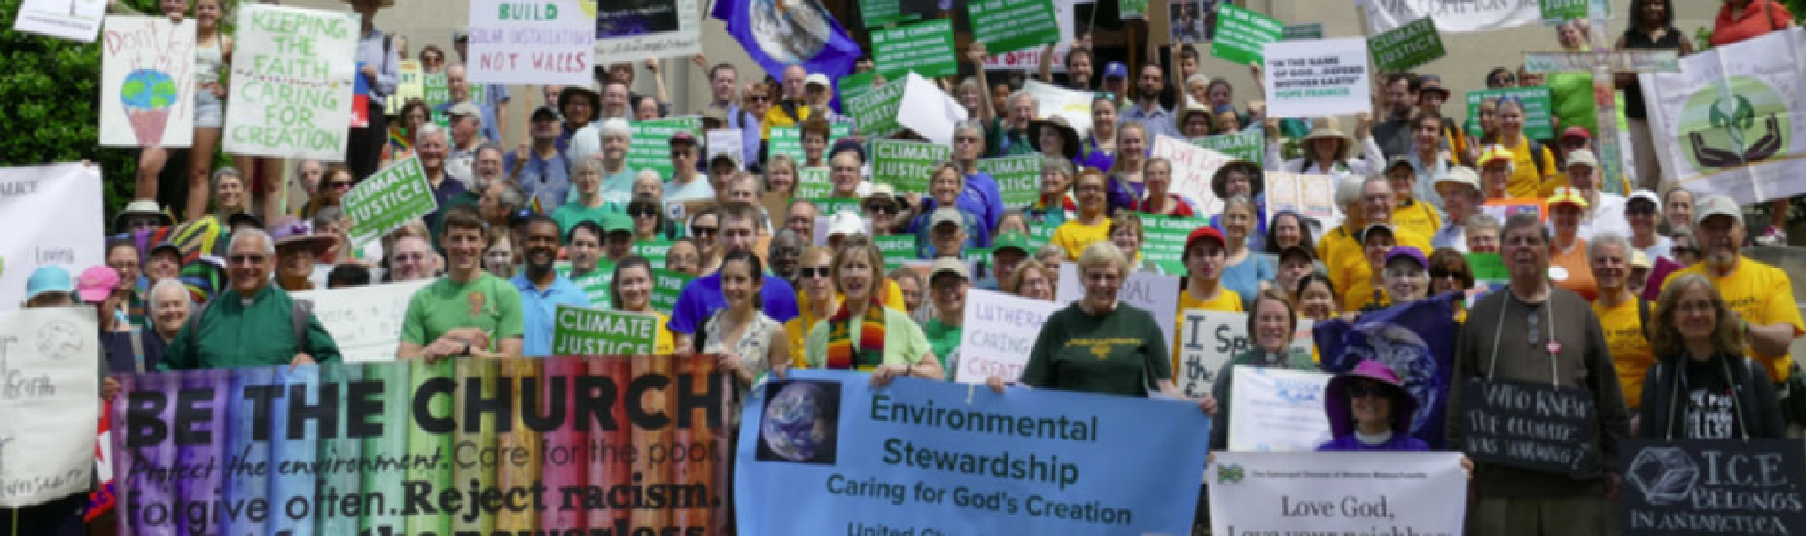

UCC and CREATION JUSTICE

Did you know…

UCC ministers coined the phrase “environmental racism” and played a leading role in giving birth to the environmental justice movement in the 1980s
During a six week campaign of civil disobedience in 1982, a movement was born that made national headlines and introduced the world to the issue of environmental racism.

Did you know…

UCC ministers coined the phrase “environmental racism” and played a leading role in giving birth to the environmental justice movement in the 1980s
During a six week campaign of civil disobedience in 1982, a movement was born that made national headlines and introduced the world to the issue of environmental racism.
In 1987, the UCC’s Commission for Racial Justice published the first report to comprehensively demonstrate environmental racism across the nation with its report Toxic Wastes and Race in the United States. A 20th anniversary report took that research further in demonstrating that when facilities were clustered together in an area the likelihood of racial and economic disparities increased. In 2020, a report entitled “Breath to the People: Sacred Air and Toxic Pollution” added another dimension of research by focusing on the children who live near polluting facilities and are particularly vulnerable toxic emissions.

The UCC has often led the way in taking denominational stands on major environmental issues
In 2013, the UCC was the first denomination to pass a resolution calling for divestment from fossil fuel companies. In 2019, the UCC was the first Christian denomination to endorse the Green New Deal.

The UCC is building a powerful environmental network that stays connected through a blog and e-newsletter called The Pollinator

The Pollinator is a digital platform of the UCC for the sharing of ideas and inspiration, so that we might become more fruitful in the pursuit of environmental justice. Its focus is the building of a faith-filled and faith-rooted movement for the care of creation. (ucc.org/category/column/the-pollinator-ucc-environmental-justice-blog)

UCC churches are deepening and expanding their commitment to the environment by becoming Creation Justice Churches

Whether it is taking on climate change or addressing the lead poisoning of children, environmental justice ministries could not have a higher purpose or calling than they do now. Join the movement and become a Creation Justice Church.

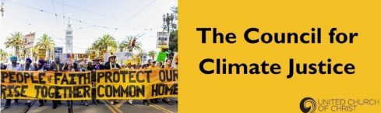

UCC Council for Climate Justice
After attending the 2015 United Nations Climate Change Conference, three UCC climate leaders sought to convene others in the UCC who were also committed to addressing climate issues. After a series of conference calls, the UCC Council for Climate Justice was established with the dual purpose of raising awareness in the UCC about climate justice and bringing people together for action.
The Council strives to have representation from all conferences in the UCC. It further strives to live out the mandates of the 2015 resolution that calls for the establishment of a national task force devoted to the transition from fossil fuels to renewable energy. The resolution further calls upon conferences to establish task forces dedicated to climate justice through the work of educating and organizing congregants as well as listening to congregants.

Through survey responses and retreats, the Council has outlined the following areas of focus:
- cultivating the kind of urgency and mobilization that is witnessed in times of war
- ratcheting up the engagement of local churches and their leaders
- going beyond a focus on individual behaviors to collectively address institutions and systems—ie., the oil industry.
- developing a pervasive prophetic culture within the Church
- advancing a perspective rooted in progressive theology and scientific understandings
- addressing the root causes of climate-related pollution as it relates to factors such as race, class, and global inequality
- sharing best practices for educating and organizing congregants
- cultivating collaborative endeavors with ecumenical, interfaith, and secular partners
- articulating the values that motivate people of faith to action through the framework of the UCC’s Three Great Loves initiative which lifts up Love of Neighbor, Love of Children, and Love of Creation.
Before jumping into envisioning where we go as a congregation, we need to affirm where we have been and where we are. We will discuss the strengths of the congregation’s ministries that have led us to this point. We give space as well, for allowing group members to name their current passions and interests in relation to creation justice.

For more information go to countrysideucc.org/discernment and click on UCC and Environmental Justice.

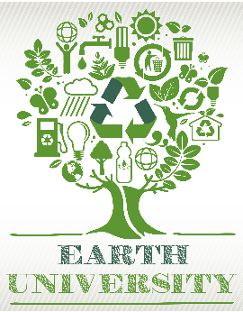
Earth University Fall 2021
Adaptation
All classes on Zoom
countrysideucc.org/calendar
Thursday, October, 14 Climate Change and Health
7:00 - 8:00 PM
Climate change affects the social and environmental determinants of health for humans and all living things- clean air, safe drinking water, sufficient food and secure shelter. Armando De Alba, Rosales, MD, MPH will help us gain a new understanding of the many ways a warming planet will impact our health and measures we can take to maintain it.
Thursday, October, 21, Transportation’s Impact on Climate
7:00 - 8:00 PM
Bringing this all closer to home, Grace Thomas of the Verdis Group, will share with us the latest information on transportation in our area and ways we can lower our own transportation emissions.
Thursday, October, 28, Katharine Hayhoe on Climate Change: Why We Must Care and What We Can Say,
7:00 - 8:00 PM
Dr. Katharine Hayhoe is well known for her ability to connect action on climate change to values, whether those values are love of God’s creation, love for our children and grandchildren or something else. She will highlight key points of her new book; Saving Us: A Climate Scientist’s Case for Hope and Healing.

Thursday, November 4, Why You Want to grow a Mini Nebraska Prairie in Your Backyard
7:00 - 8:00 PM
Tonight we will be joined by Sarah Leuder and Kate Nootenboom, the Hubbard Fellowship Scholars working with Chris Helzer, renowned naturalist and The Nature
Conservancy’s Director of Science in Nebraska.. they will bring us up to date on restoring land and conservation programs as well as give advice on how to create mini prairies in our backyards.

For more in-depth information about each topic go to:
countrysideucc.org/learning-together/fate

