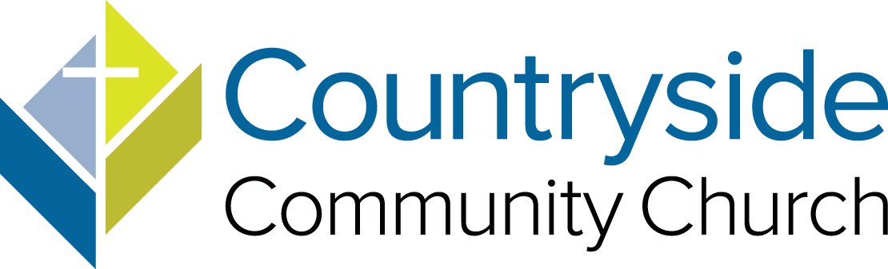

FOR IMMEDIATE RELEASE

Countryside Community Church Hosts Rev. Dr. Molly Marshall and Dr. Munjed M. Murad for Inspiring Theological and Interfaith Event

[Omaha, NE, June 8, 2023] – Countryside Community Church is thrilled to announce the upcoming visit of Rev. Dr. Molly Marshall and special guest Dr. Munjed M. Murad of United Theological Seminary of the Twin Cities. The weekend, June 17 and 18, promises to be an enlightening and transformative experience filled with interfaith dialogue and a celebration of hospitality.

Rev. Dr. Marshall is a renowned theological figure, celebrated as a trailblazing leader, social activist, and towering intellectual. She has dedicated her life to exploring the intersections of faith, justice, and spirituality, and her contributions have left an indelible mark on theological discourse. Dr. Marshall's insights have guided countless individuals in their journeys of faith and encouraged dialogue across diverse perspectives.

Dr. Murad is a faculty member and the first full-time Muslim scholar at United. He’s also the Program Director for the school’s new Eco-Justice concentration and serves as Assistant Professor of World Religions and Intercultural Studies, supported by the Johnson-Fry Endowment. Dr. Murad brings a unique perspective and a wealth of knowledge to the discussion. His presence underscores the commitment of Countryside Community Church to foster interfaith dialogue and understanding.

"We’re honored to host Rev. Dr. Marshall and Dr. Murad at Countryside Community Church," said Rick MacInnes, Countryside Church Council At-Large, and Board of Directors Vice Chair for the Tri-Faith Initiative. "Their presence and insights will enrich our community and deepen our commitment to building bridges of understanding and friendship among people of different faiths."

The weekend will begin with a welcoming reception at Countryside on Saturday, June 17, from 4-6 p.m., providing attendees with an opportunity to connect with Rev. Dr. Marshall, Dr. Murad, and fellow community members. The reception provides an opportunity to share stories, exchange ideas, and build bridges of understanding.

On Sunday, June 18, Rev. Dr. Molly Marshall will deliver a special Sunday Sermon, "The Birthing Power of Hospitality." This thought-provoking talk will explore the profound impact of hospitality within the context of interfaith relationships, emphasizing the transformative potential that arises when diverse communities come together in unity and respect.

Countryside Community Church, a vibrant and inclusive faith community, is committed to promoting interfaith relationships and fostering dialogue across traditions. This event is a testament to their dedication to creating spaces where diverse perspectives are welcomed and valued.

This event is open to everyone interested in exploring interfaith relationships and promoting understanding across diverse communities. Attendees are encouraged to join us at Countryside Community Church on June 17 and 18 for an enlightening weekend that will inspire meaningful conversations and transformative connections.

About Countryside Community Church
Countryside Community Church is an inclusive, open, and affirming family of faith, dedicated to promoting justice, love, and compassion. We’re diverse, yet united by Christ’s example. Through engaging worship, inspiring education, and meaningful outreach, Countryside Community Church strives to make a positive impact in the lives of individuals and the broader community. We work together to nurture our community and promote peace, equality, and justice in our conflicted world.

About United Theological Seminary of the Twin Cities
Founded as a welcoming, ecumenical school that embraces all denominations and faith traditions, United Theological Seminary of the Twin Cities has been on the cutting edge of progressive theological thought leadership since it was established in 1962. Today, United continues to train leaders who dismantle systems of oppression, explore multi-faith spirituality, and push the boundaries of knowledge.

Contact Information
Christine Kasel, Director of Communications
Countryside Community Church
13130 Faith Plaza
402-884-0350
christinek@countrysideucc.org
www.countrysideucc.org

